ELIGIBILITY CERTIFICATION OF (2020)
SNLE - SDLE - SMLE - SPLE
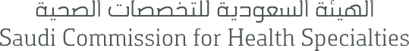

This completed form must be received by SCFHS foe each application submitted.
The application process is not complete without this form
Student name:
National/Residence ID#:
Type of Examination:
- Saudi Medical licensure Examination (SMLE)

- Saudi Dental licensure Examination (SDLE)
- Saudi Nursing licensure Examination (SNLE)
- Saudi Pharmacist licensure Examination (SPLE)

- Student in ……………………………. Year
OR
- Intern – Period from …………. to ……………
- Graduation year (e.g. 2020) 2020

I certify that this student is currently enrolled in the University/ College and is eligible to register for the examination stated above.
Printed Name of Dean Or Designee | Prof. Mohammed bin Yahya Arishi
Name of Dean or Designee
Name of University/College | Jazan University – College of Nursing
City/Branch ( if applicable) | Jazan

OFFICIAL STAMP

Date : 16/12/2020
Mock test score for student training and preparation only and cannot be used for any other purposes.
Mock test attempts are unlimited at any study year.

